Preschool Writing Descriptors
1st Quarter

• Simple but recognizable person
• Face, body, arms, legs
• Demonstrates some control
• Students work is recognizable but lacks important detail critical to the story
• Teacher labels object using words, simple phrase or sentence about story

La Conner Elementary School Writing Descriptors

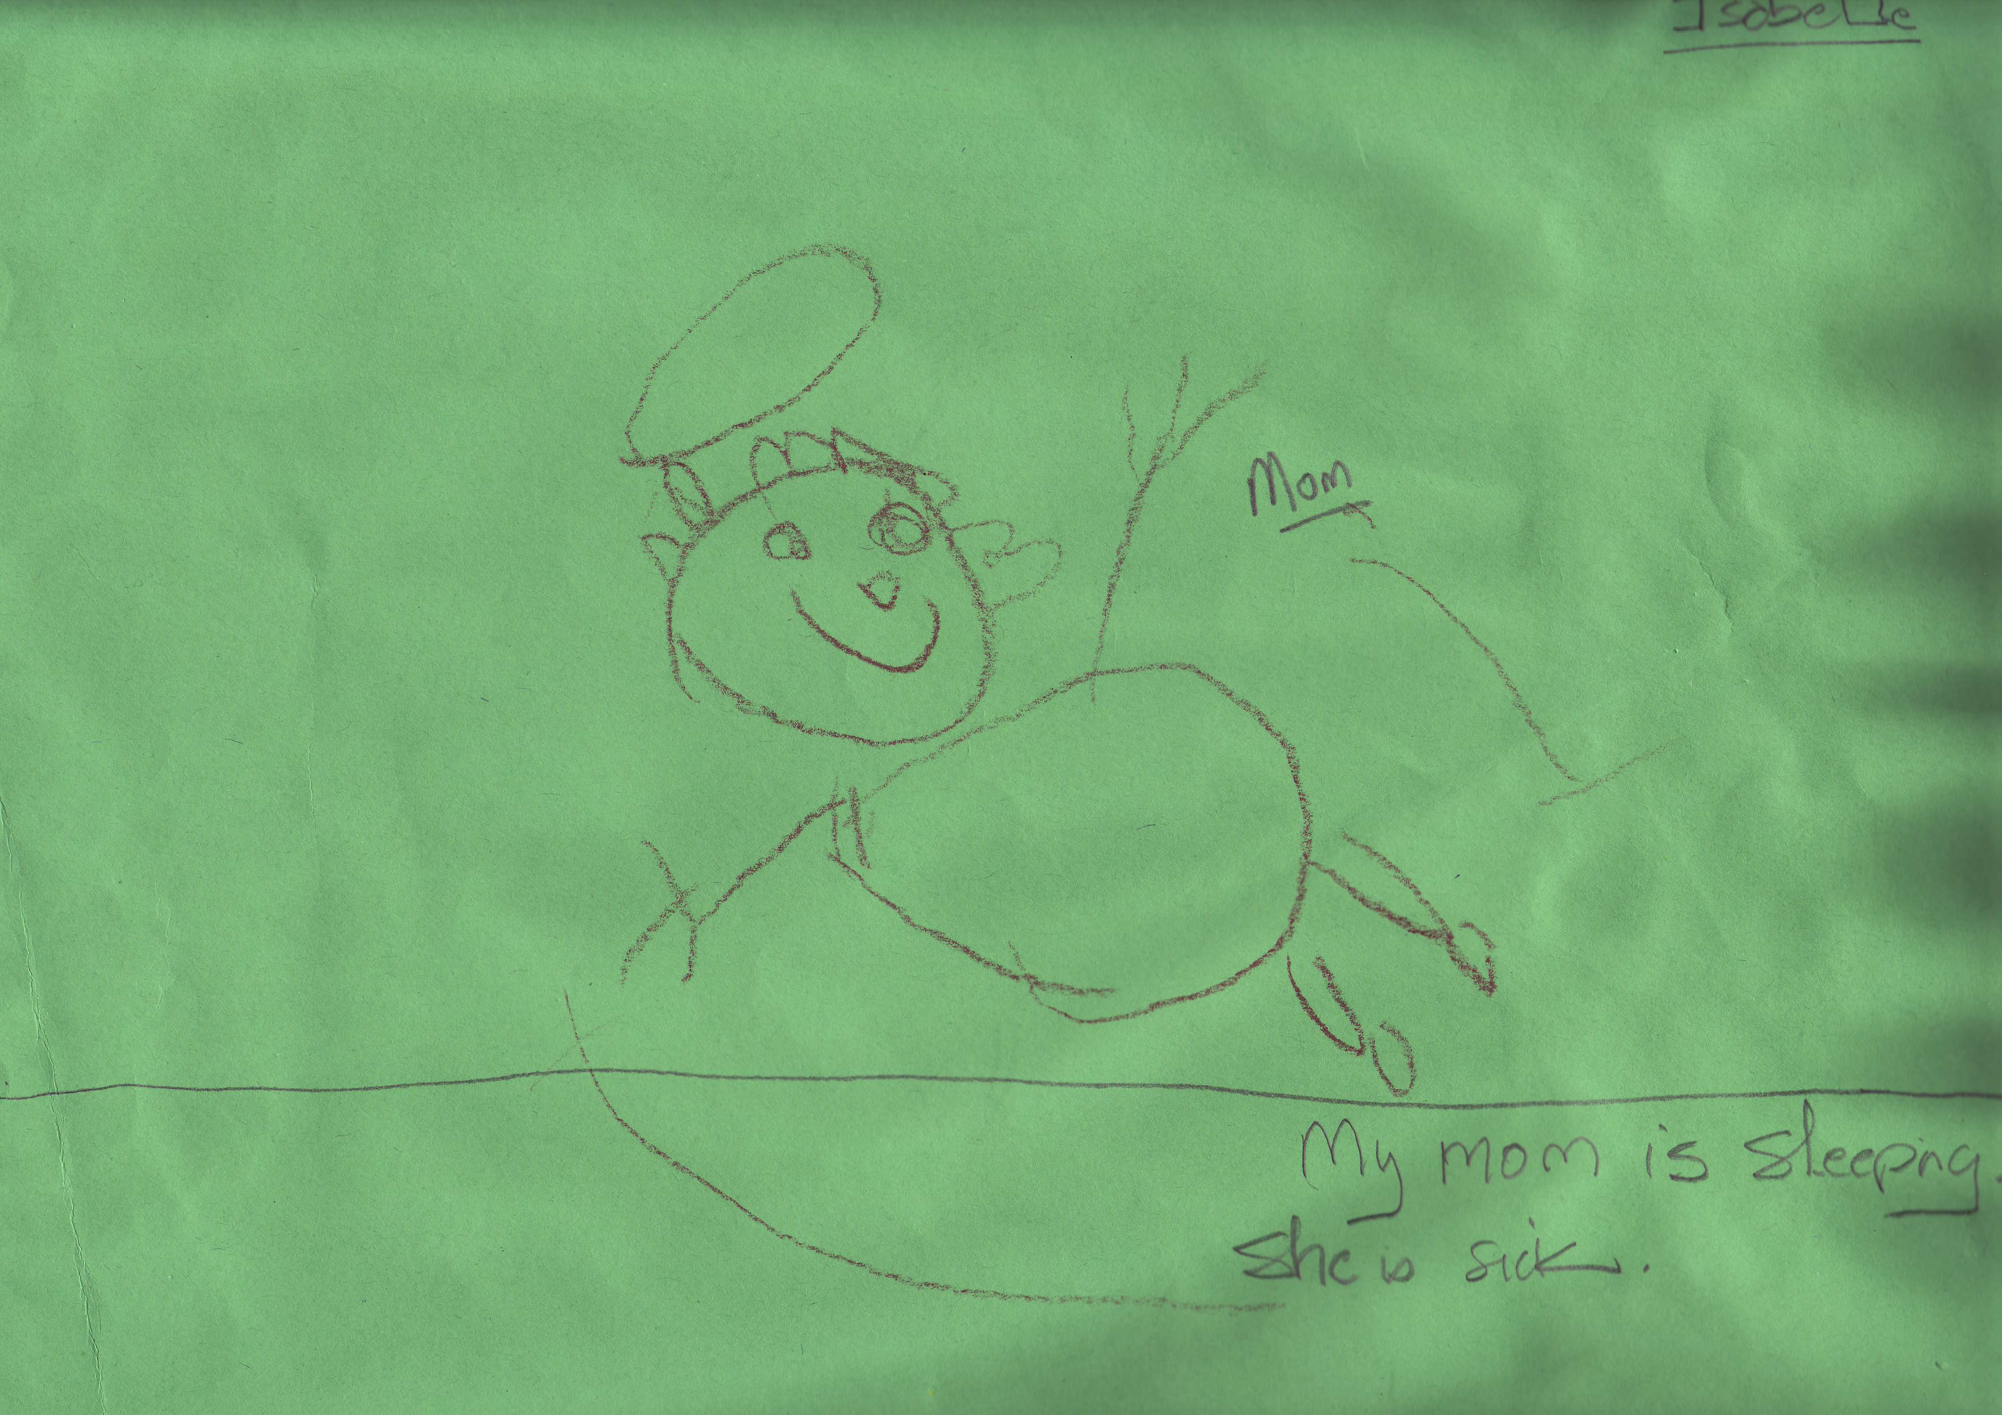

Preschool Writing Descriptors
2nd Quarter

• Recognizable figures/illustrations
• Added details to illustration
• Labeling/Naming figures
• Student dictates words and or short phrases/simple sentences including a setting and significant event
La Conner Elementary School Writing Descriptors
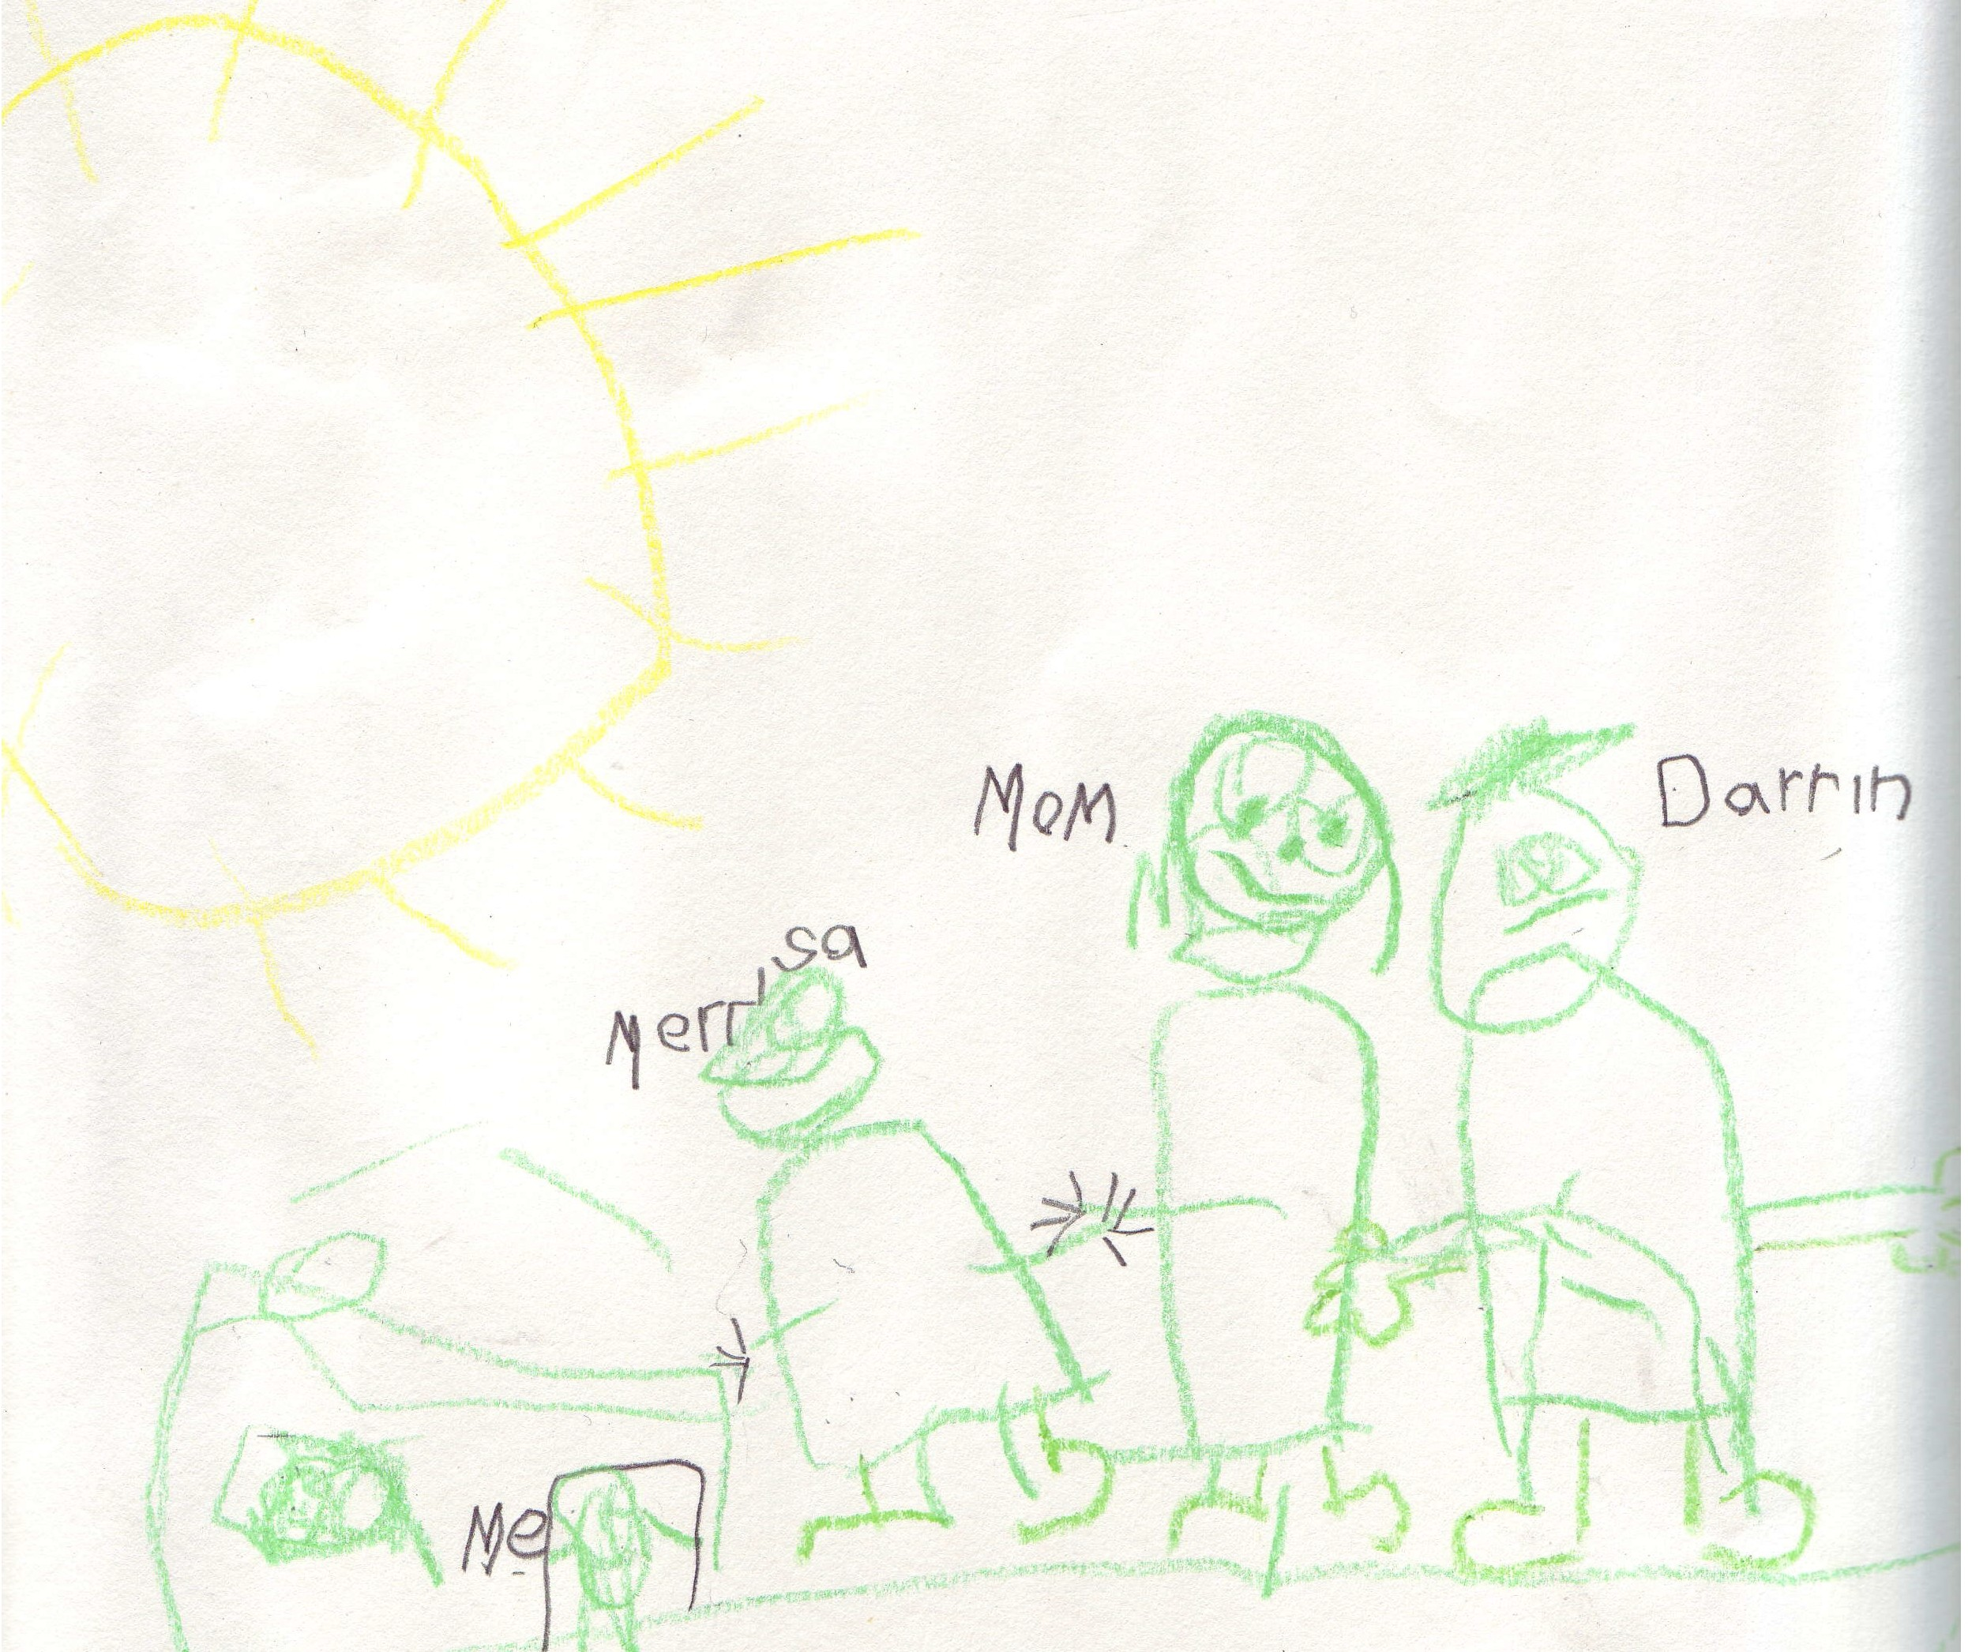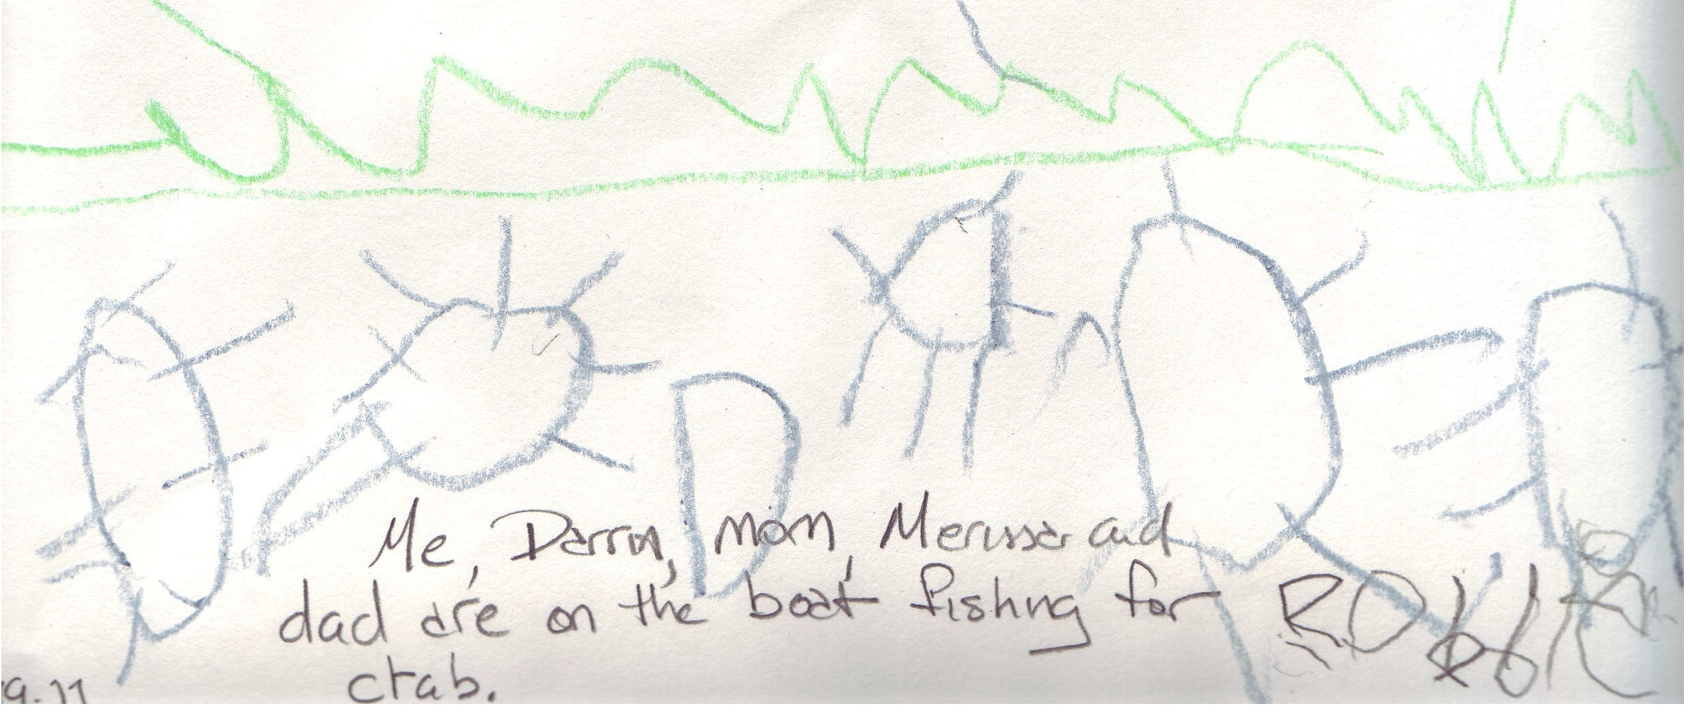

Preschool Writing Descriptors
3rd Quarter

• Recognizable
• Important details including in illustration
• Lacks student “writing”
• Some independent student labeling
• Student able to tell story through teacher questioning
'Writin-g Descriptors

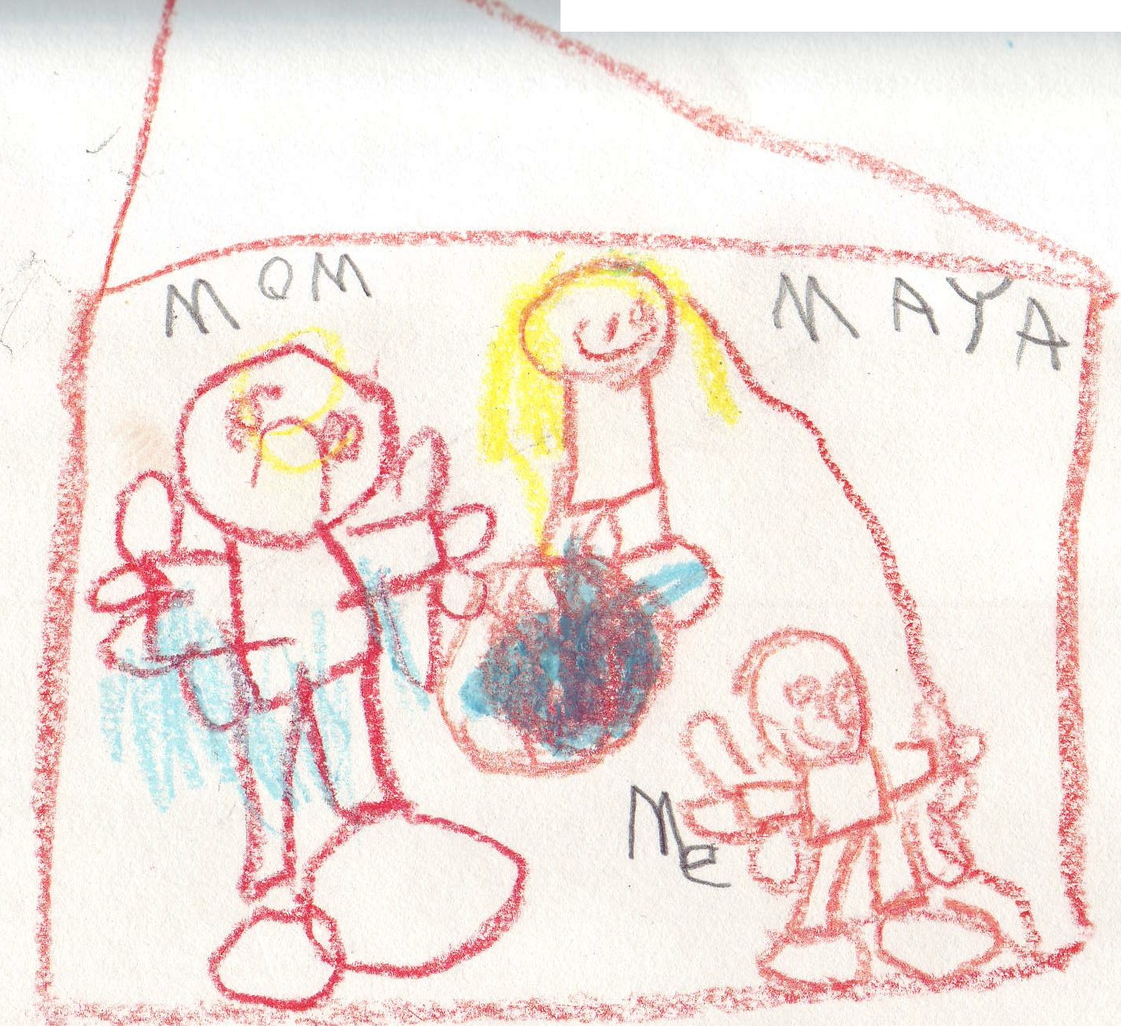

I



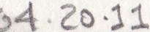
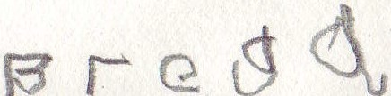

Preschool Writing Descriptors
4th Quarter

• Work contains detail critical to the story
• Includes student “writing” (speech and thought bubbles, noises)
• Student able to tell a simple story about/consistent with illustration with little or not teacher support
riting Descriptors

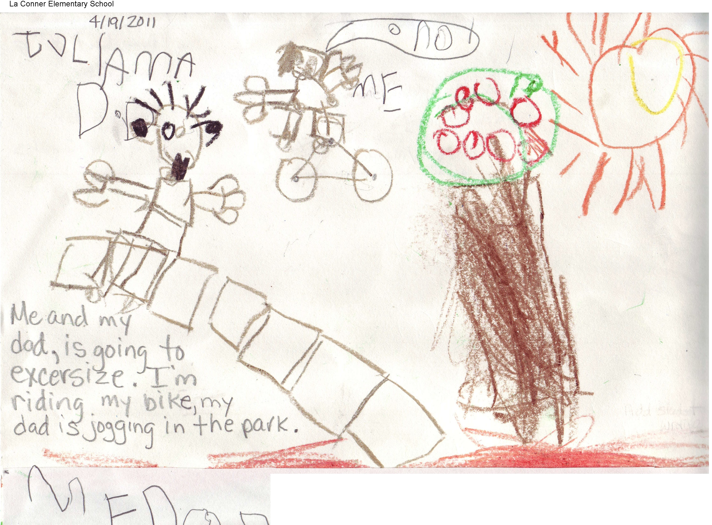

Kindergarten Writing Descriptors
1st Quarter

• There is a representation of some sort of writing below the line.
• Contains some sort of “writing” within the picture such as labels, speech bubbles, thought bubbles or noises (some teacher, some student).
• There is evidence of a character, setting, event/action within the picture. (This might be teacher supported)
• Oral language/Dictation
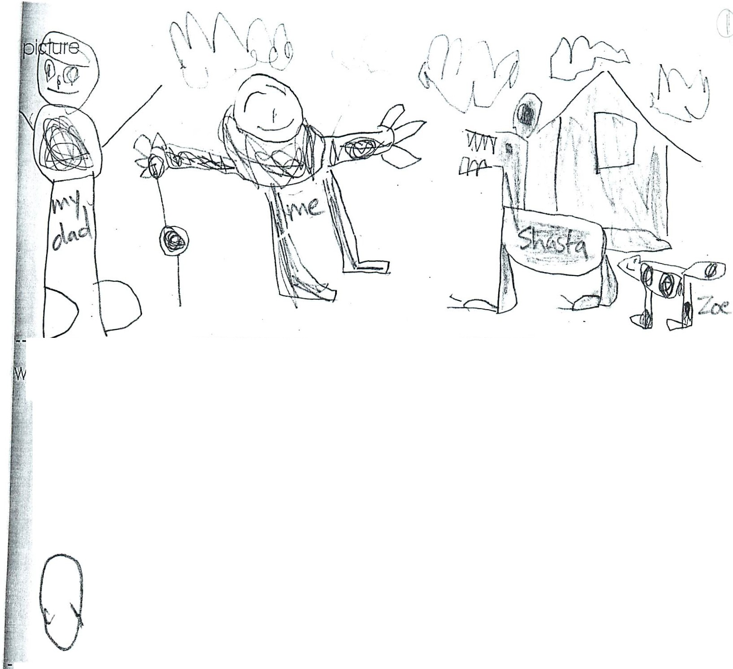

----------------------.----------_----------------.------------------. --------------------..---
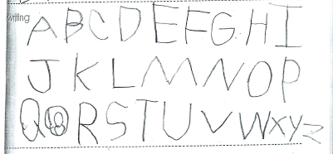
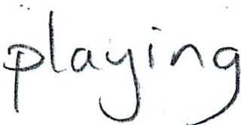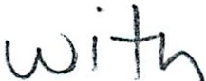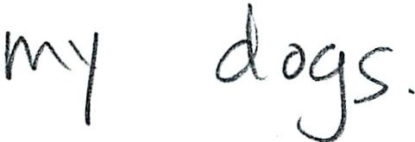
Story
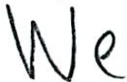

Kindergarten Writing Descriptors
2nd Quarter

• There is one line of text beneath picture with evidence of beginning sound identification.
• Continues to contain some sort of “writing” within the picture such as labels, speech bubbles, thought bubbles or noises (some teacher, some student).
• There is evidence of a character, setting, event/action within the picture.
• Begins to show an understanding of word spacing.
• Oral language/dictation
La Conner Elementary School Writing Descriptors

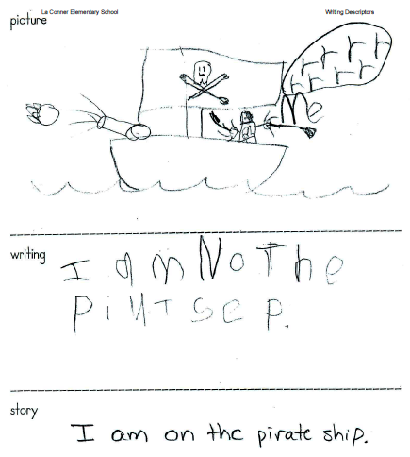

Kindergarten Writing Descriptors
3rd Quarter

• There is evidence of a character, setting, event/action within the picture.
• Contains a lengthening line of text or two sentences.
• Contains beginning and ending sounds and some correctly spelled words.
• Words written are directly related to the picture.
• Word spacing becomes more consistent
• Oral language/Dictation
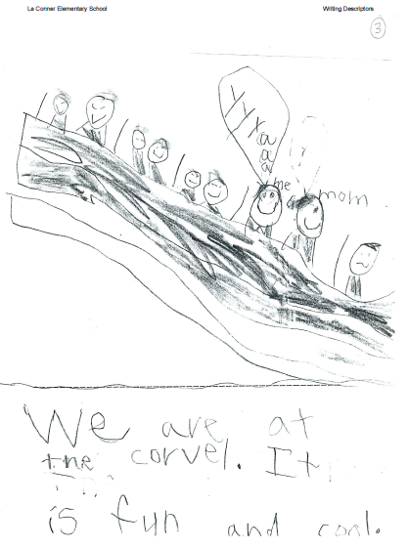
La Conner Elementar y School Writing Descriptors

Kindergarten Writing Descriptors
4th Quarter

• There is evidence of a character, setting, event/action within the picture.
• There is a two-­‐part sketch plan; a beginning and an end.
• Contains some descriptive detail and dialogue in the pictures.
• Contains two sentences relating to the beginning and the end.
• Contains correctly spelled selected sightwords.
• Contains many closely spelled words and words with beginning, middle and ending sounds.
• Word spacing is consistent.

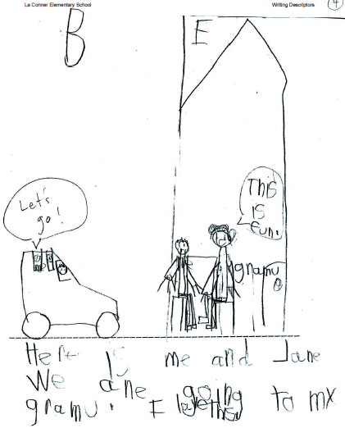

1st Grade Writing Descriptors
1st Quarter

Descriptors include essential kindergarten 4th quarter descriptors and:
• Uses a 3 part plan (beginning, middle, end)
• Writes 3 sentences
• Sentences match the drawings
• Drawings include: labels, speech or thought bubbles,character, and setting
• Writing includes: spacing, lowercase letters, and evidence of capital letters at the beginning of sentences and ending punctuation
• Knows 75-­‐100 words

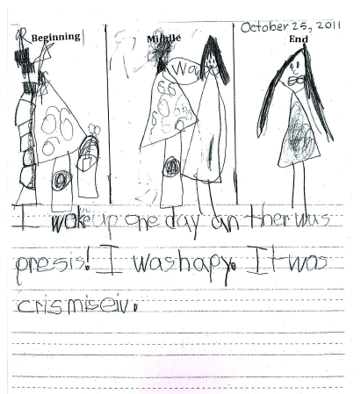

1st Grade Writing Descriptors
2nd Quarter

Descriptors include previous essential 1st grade descriptors and:
• A title
• Writes 4-­‐5 sentences
• Selects topic themselves
• Knows 100-­‐125 words
• Capitalizes first names, proper nouns, and the beginning of sentences
• Writing includes: character, setting, and significant event

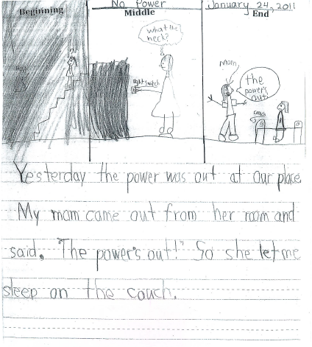

1st Grade Writing Descriptors
3rd Quarter

Descriptors include previous essential 1st grade descriptors and:
• A 4-­‐part plan (beginning, middle, middle, end)
• Dialogue appears in writing
• May have more than one character
• Knows 125-­‐150 words
• Includes 5-­‐7 sentences
• Begins to identify audience (reader)
• Carries story on for two days
• Uses descriptive words and supporting details
• Proofreads for spelling and punctuation
• Writing expresses emotion
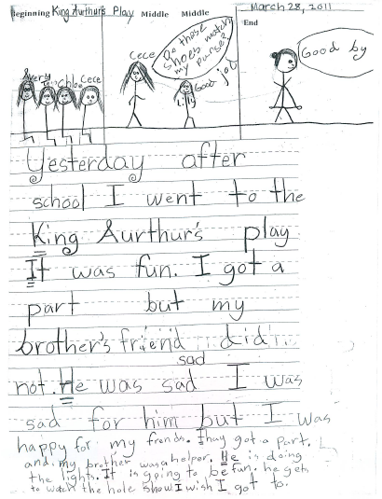

1st Grade Writing Descriptors
4th Quarter
Descriptors include previous essential 1st grade descriptors and:
• Writes 6-­‐8 sentences
• Knows 150-­‐175 words
• Writing matches story plan (B.M.M.E)
• Makes adjustments, (may add or take away
• Proofreads for spelling, grammar, and punctuation
• Begins to publish story
• Carries story over a longer period of time
• Begins to identify expository writing. 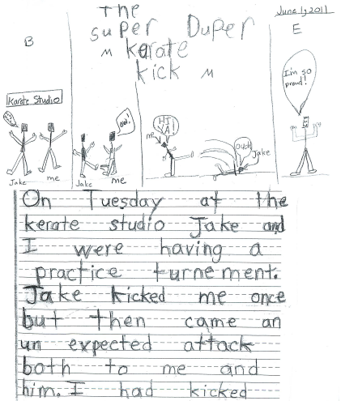
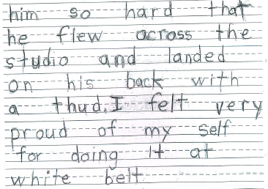

2nd Grade Writing Descriptors
1st Quarter

• Beginning, Middle, End with details
• Dialogue, setting, characters
• 8-­‐10 sentences
• Descriptive words
• Spelling – more use of complex letter sounds/sound relationships
– sight words
• Evidence of editing and revision

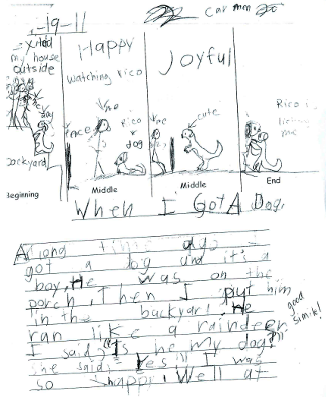
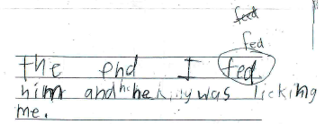
2nd Grade Writing Descriptors
2nd Quarter

• Beginning, Middle, End
• Minimum of 3 transitions
• Dialogue, setting and characters
• Uses a beginning statement to introduce writing
• Some descriptions
• Evidence of editing and revision
• Ten to twelve sentences

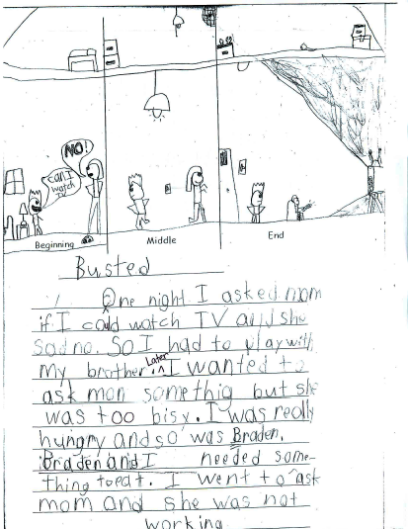

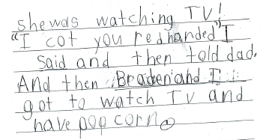

2nd Grade Writing Descriptors
3rd Quarter

• Beginning, Middle, Middle, End
• Minimum of four transition words
• Dialogue (may be single word)
• Opening and closing sentence (beginning paragraph development)
• Clear setting and character
• Some adjectives or descriptions
• Evidence of editing and revision
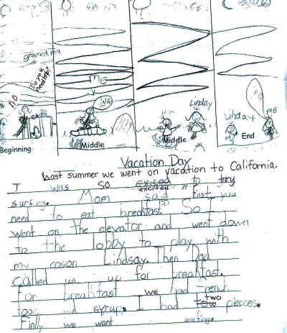

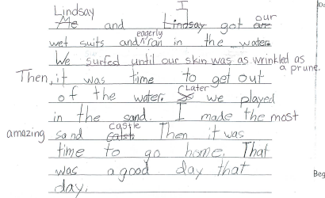

2nd Grade Writing Descriptors
4th Quarter

• Beginning, middle, middle, end (sequential, ordered applicable events)
• Transition words
• Dialogue with exchange
• Opening sentence and closing sentence (paragraph with one topic & support
• details)
• Clear setting (maybe more than one setting)
• More than one main character
• Adjectives and descriptions
• Appropriate Title
• Evidence of editing and revision

